HDP Setup : Ubuntu 18.01

Setup Ubuntu 18.x in VMBOX

Install packages

apt-get install vim

apt-get install wget

apt-get install ntp

apt-get install open-ssh

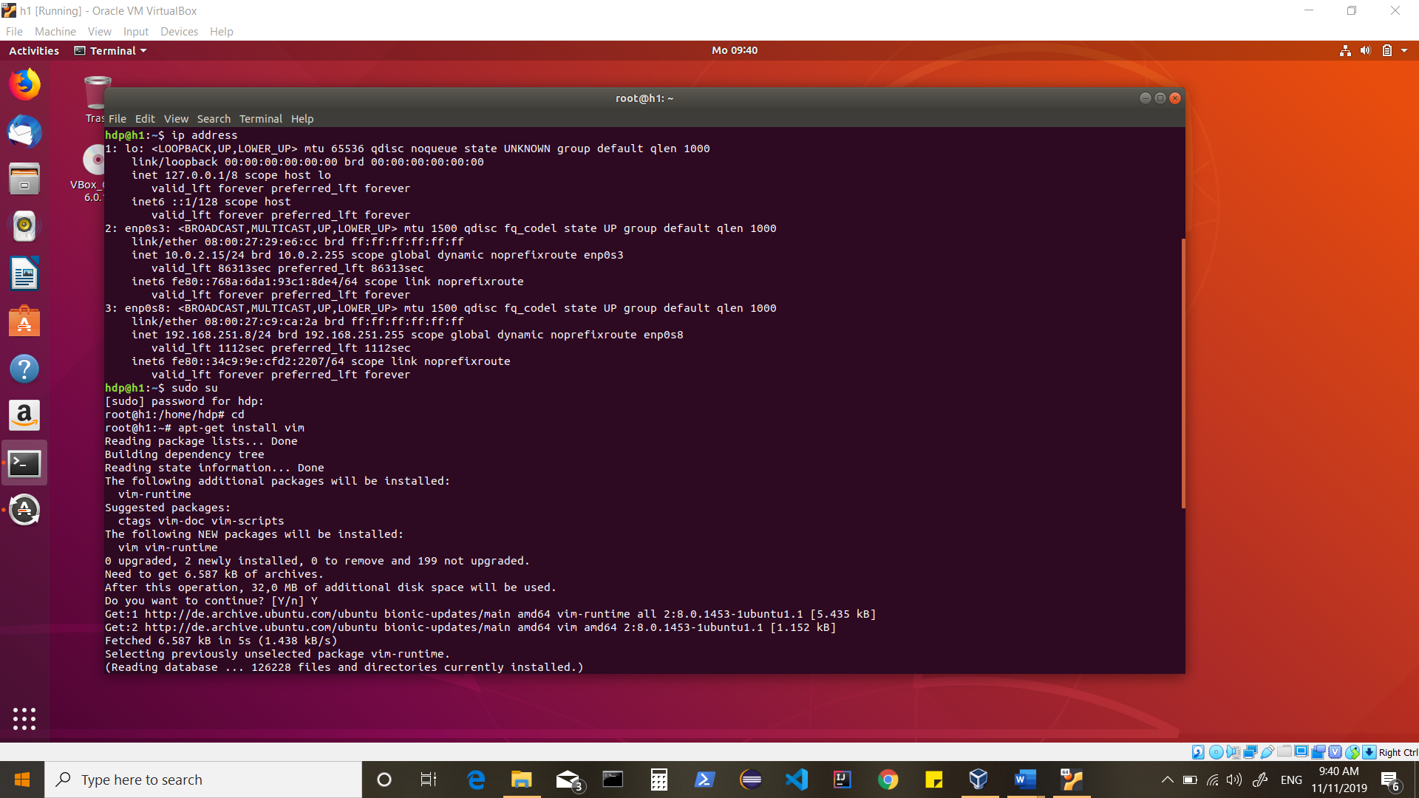

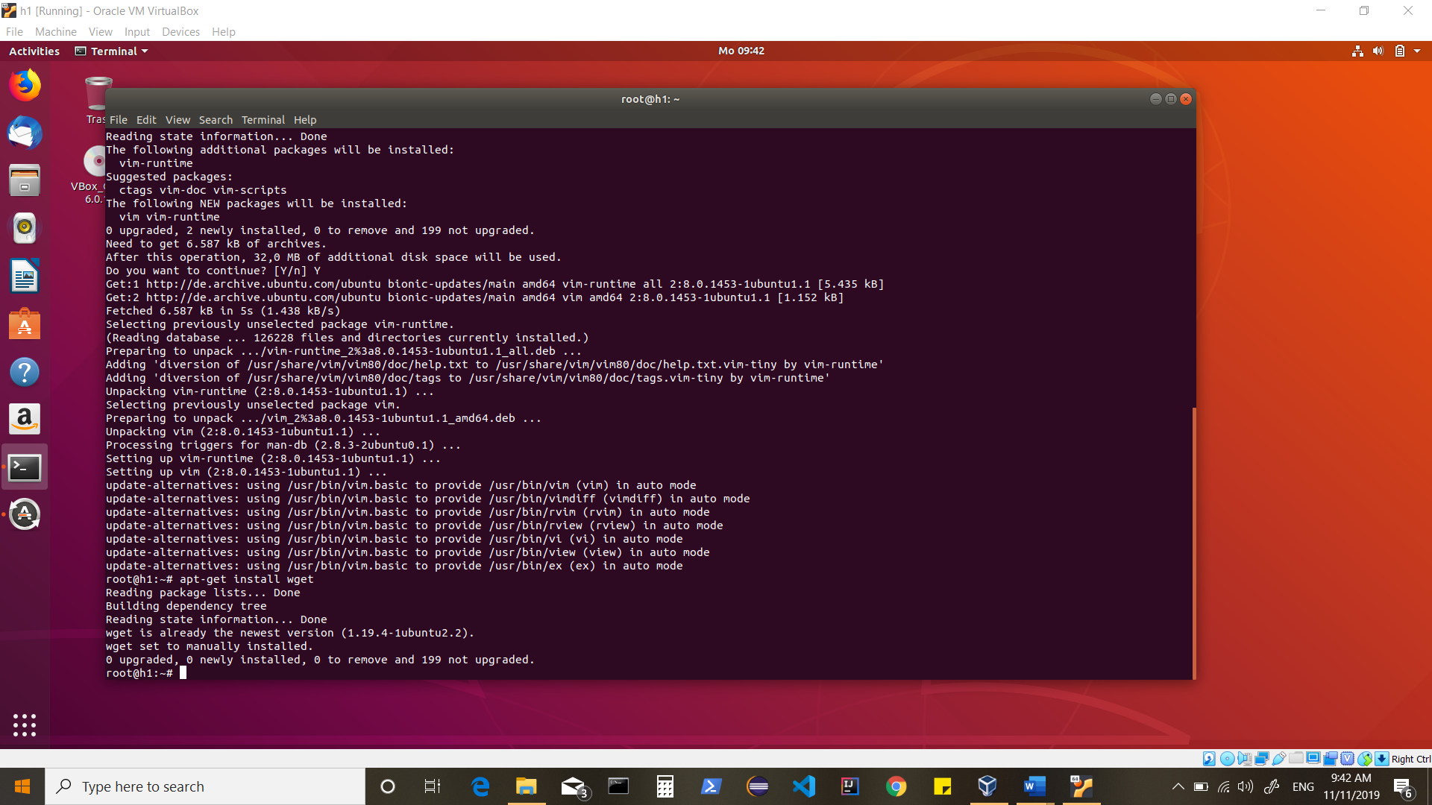

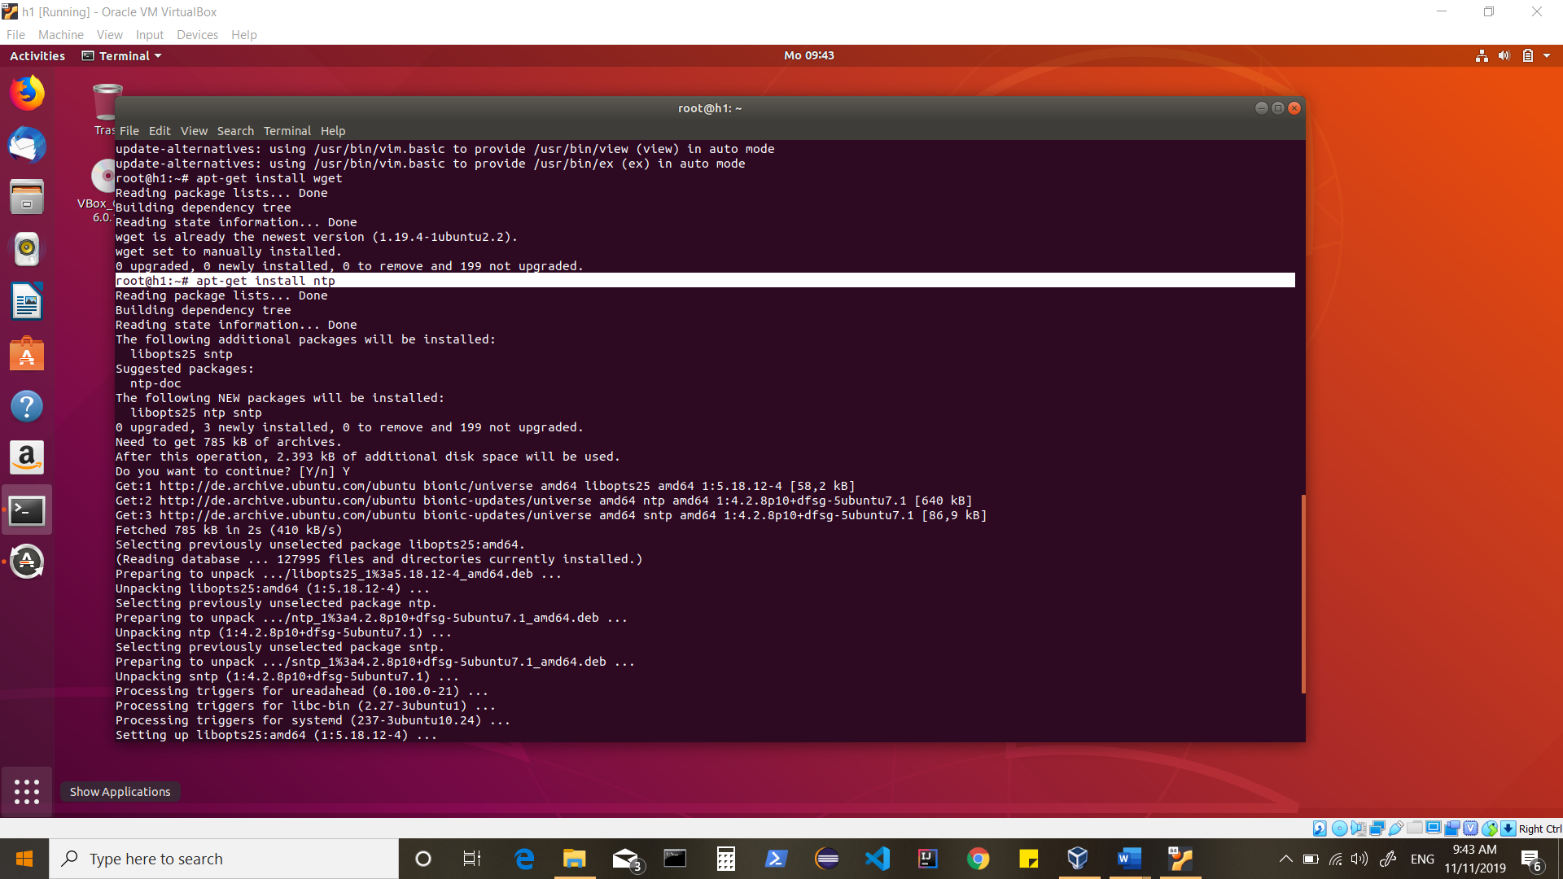

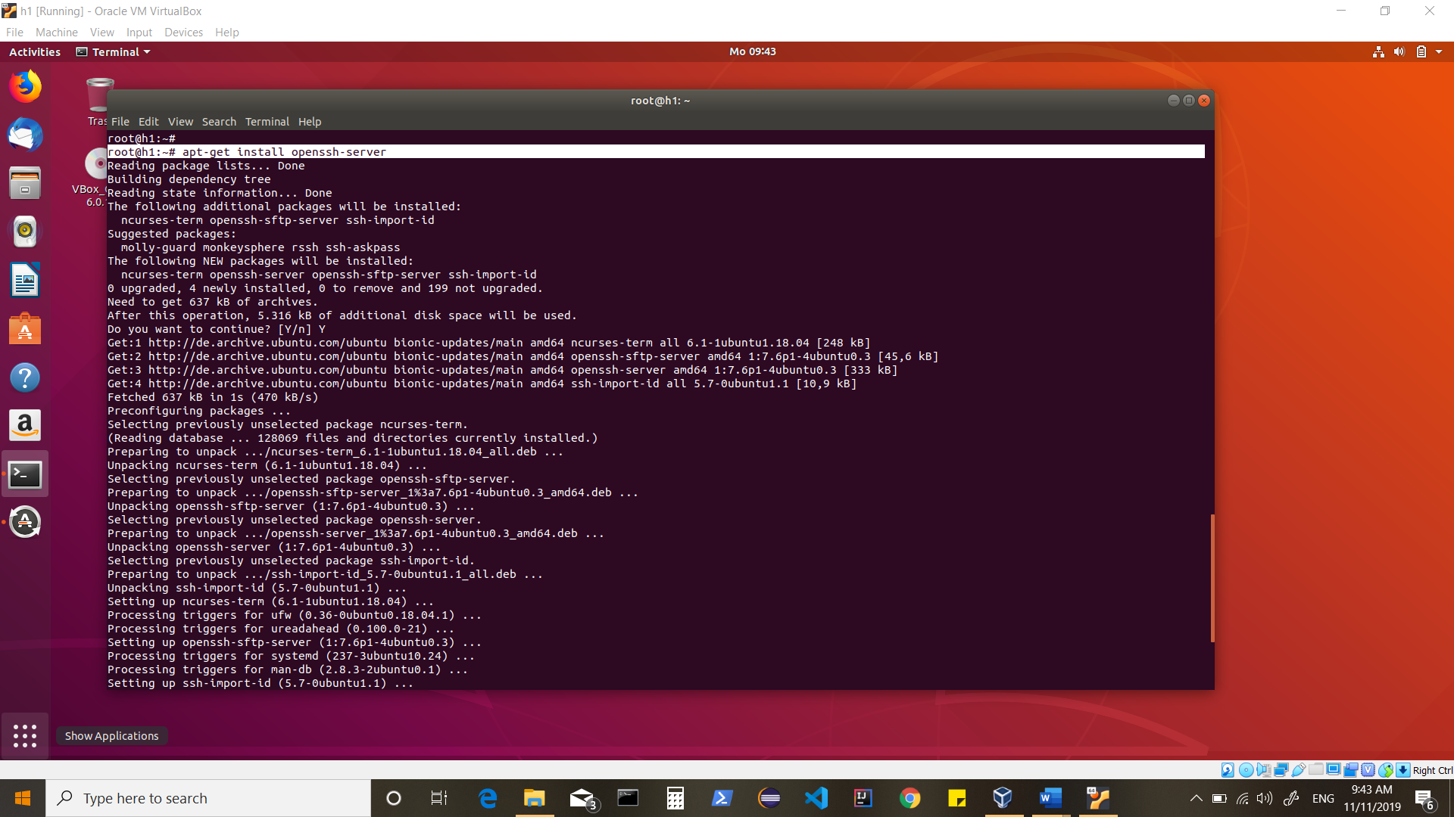

Disable firewall

Update hostname in /etc/hostname and ipaddress in /etc/hosts

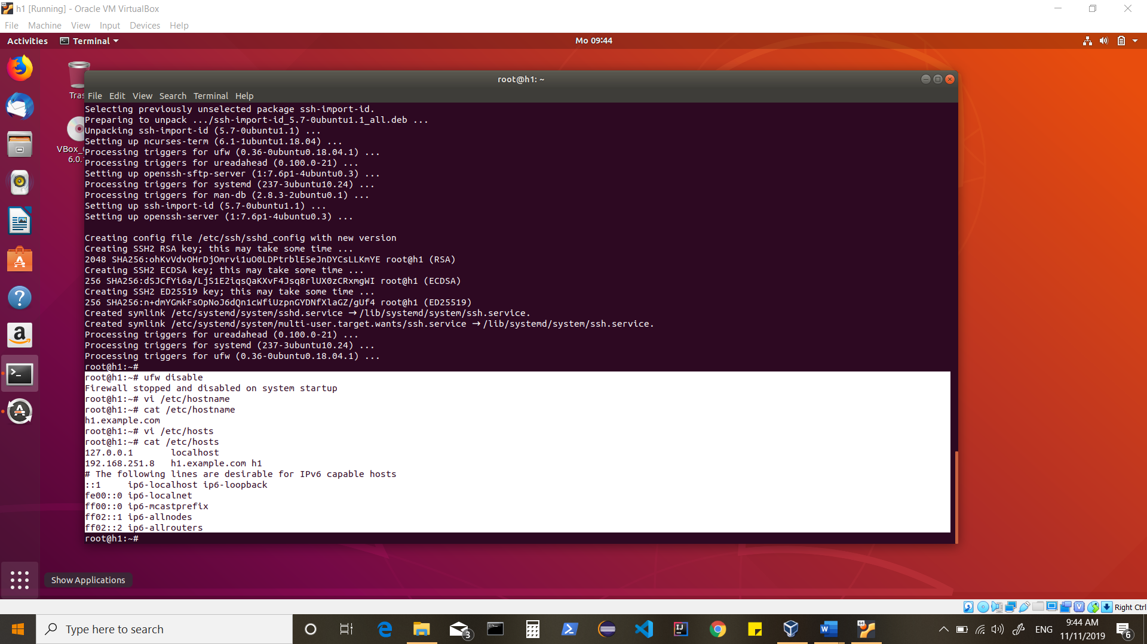

update/change password for root

[root@h1: passwd]

Edit /etc/ssh/sshd_config

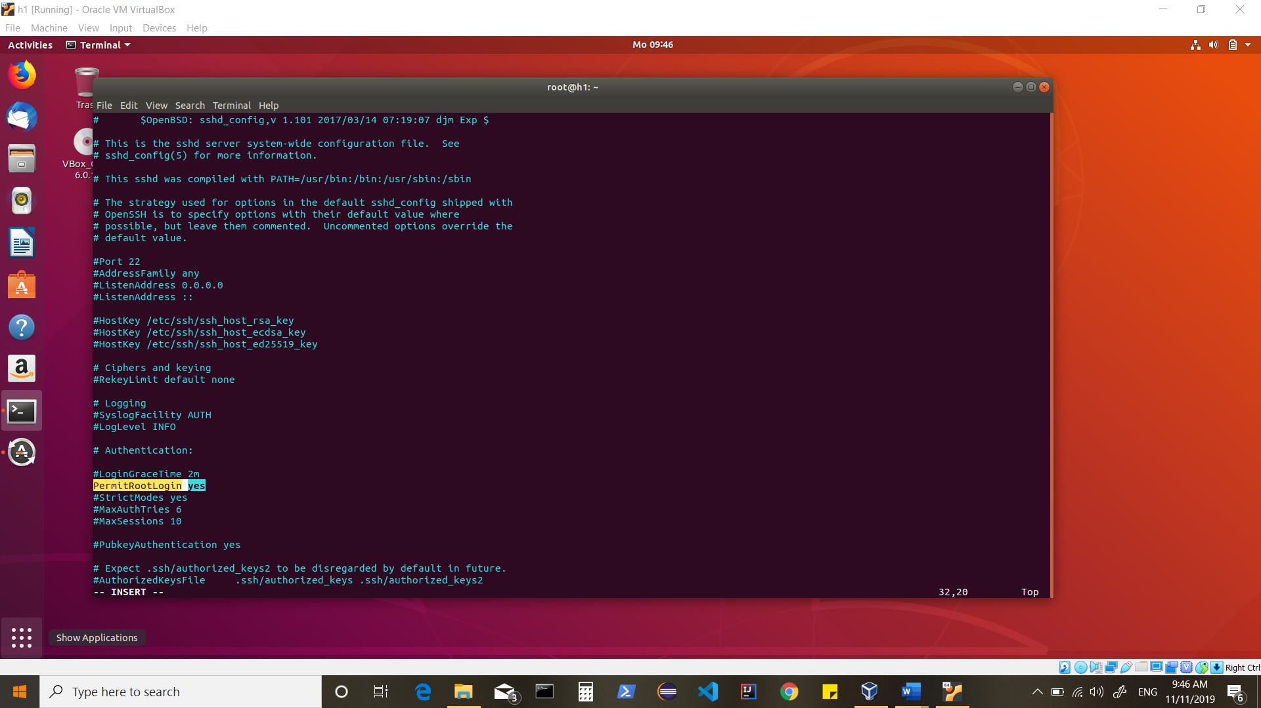

[reboot]

[service ntp start]

[apt-get update]

--Now clone the machine to create 2 more machines within your VMBOX.

--Change the IPs and Hostnames in newly created machines.

--My setup has

h1.example.com

h2.example.com

h3.example.com

--Setup SSH Access (password less) for root user between these machines.

[root@h1:~#ssh-keygen -t rsa -P „„]

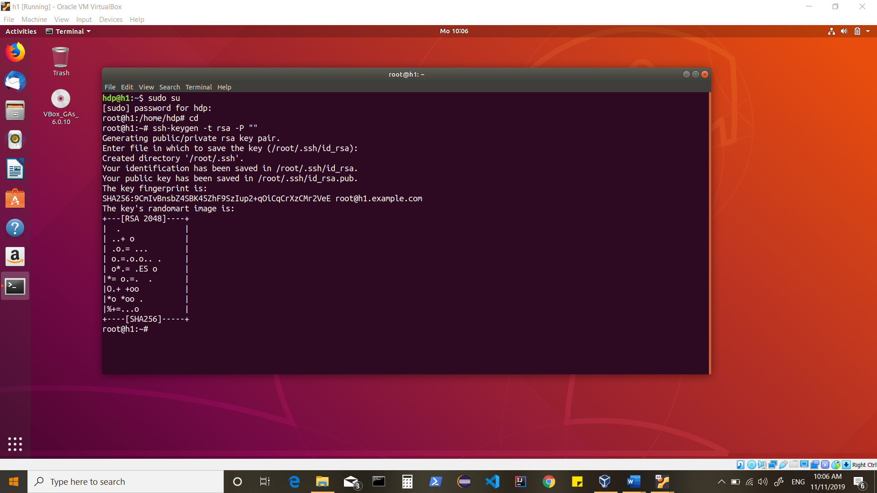

--Similarly on other 2 nodes.

--Copy SSH public keys

[root@h1:~#ssh-copy-id -i $HOME/.ssh/id_rsa.pub root@h2]

[root@h1:~#ssh-copy-id -i $HOME/.ssh/id_rsa.pub root@h3]

[root@h2:~#ssh-copy-id -i $HOME/.ssh/id_rsa.pub root@h1]

[root@h2:~#ssh-copy-id -i $HOME/.ssh/id_rsa.pub root@h3]

[root@h3:~#ssh-copy-id -i $HOME/.ssh/id_rsa.pub root@h1]

[root@h3:~#ssh-copy-id -i $HOME/.ssh/id_rsa.pub root@h2]

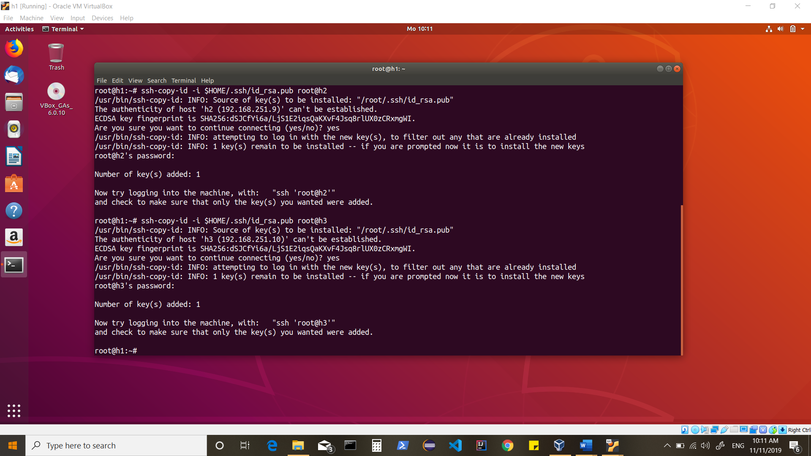

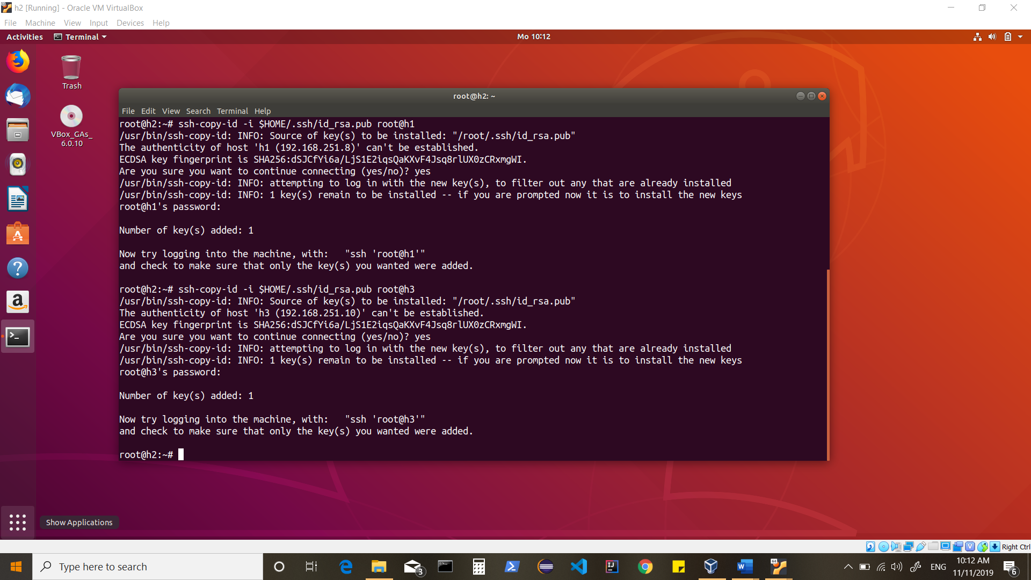

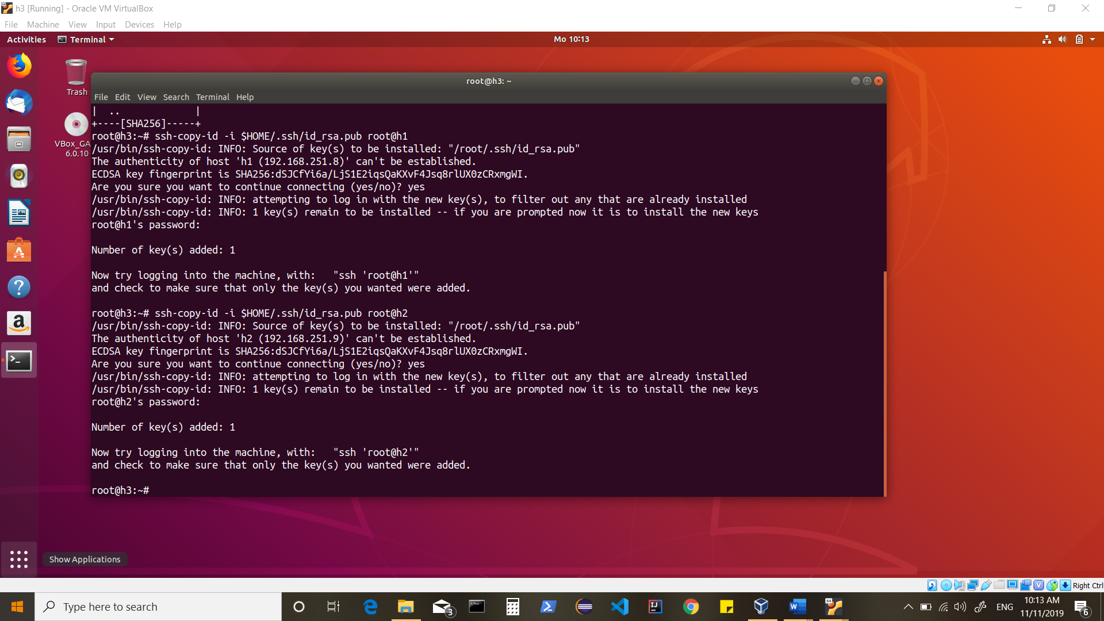

--Also append ssh public key to itself (on every node) & test SSH Access to itself and other nodes.

[root@h1:~#cat $HOME/.ssh/id_rsa.pub >> $HOME/.ssh/authorized_keys]

[root@h2:~#cat $HOME/.ssh/id_rsa.pub >> $HOME/.ssh/authorized_keys]

[root@h3:~#cat $HOME/.ssh/id_rsa.pub >> $HOME/.ssh/authorized_keys]

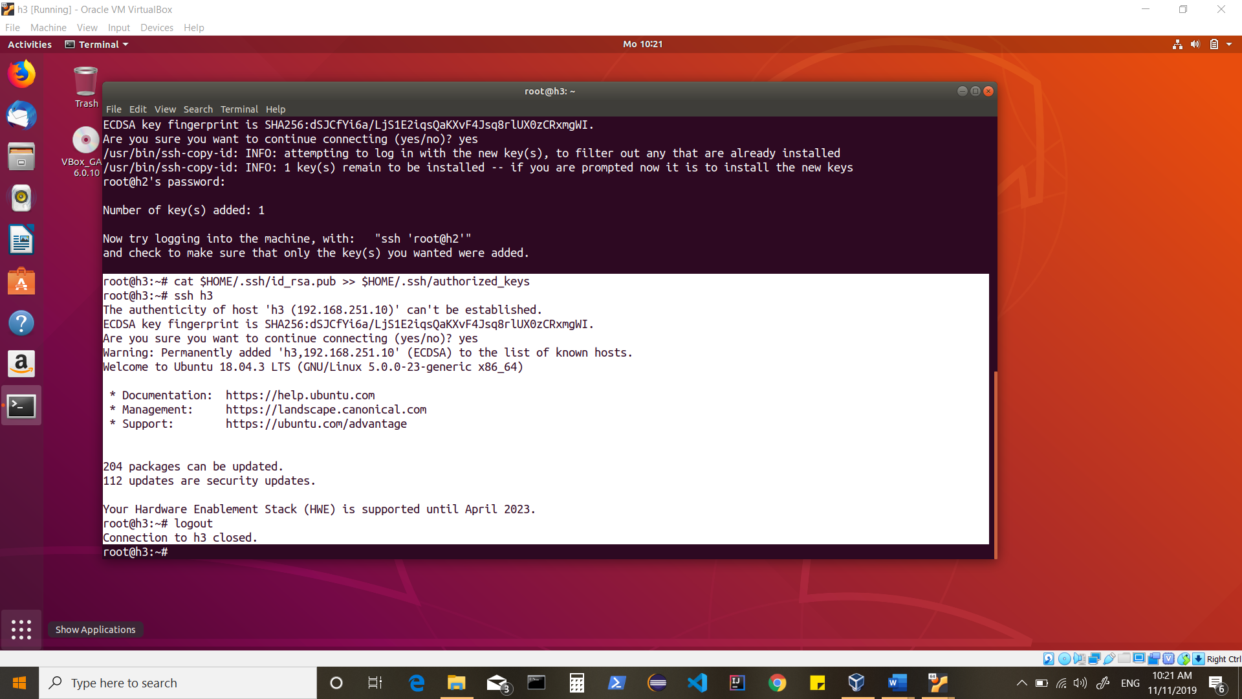

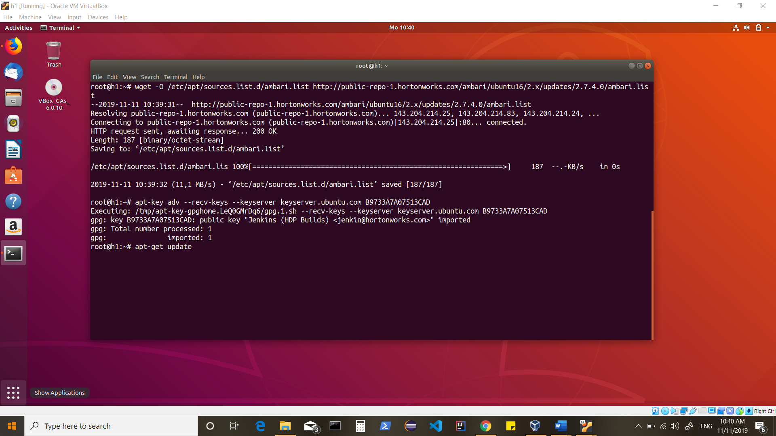

Start with Ambari setup on one of the nodes [in My case : h1]

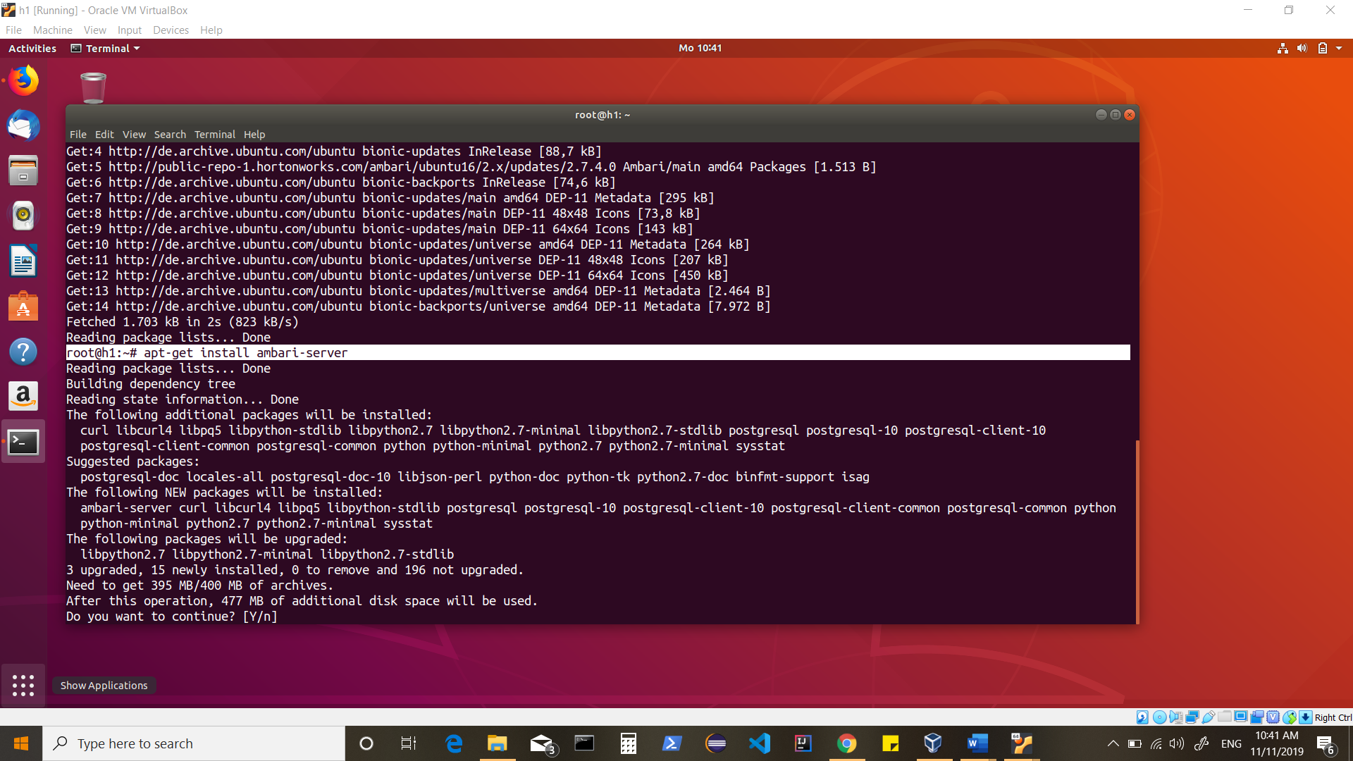

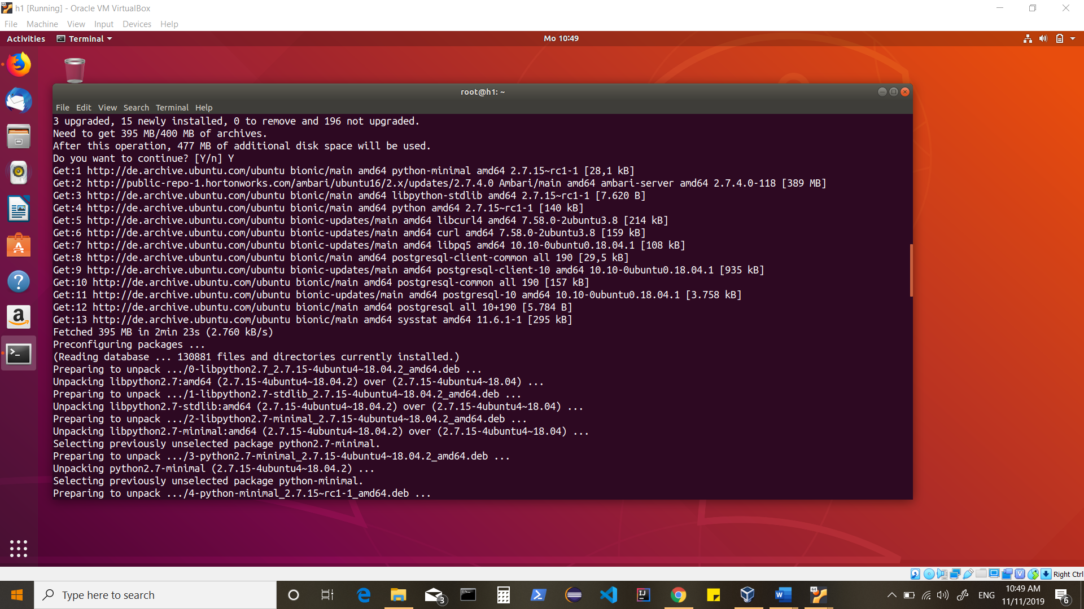

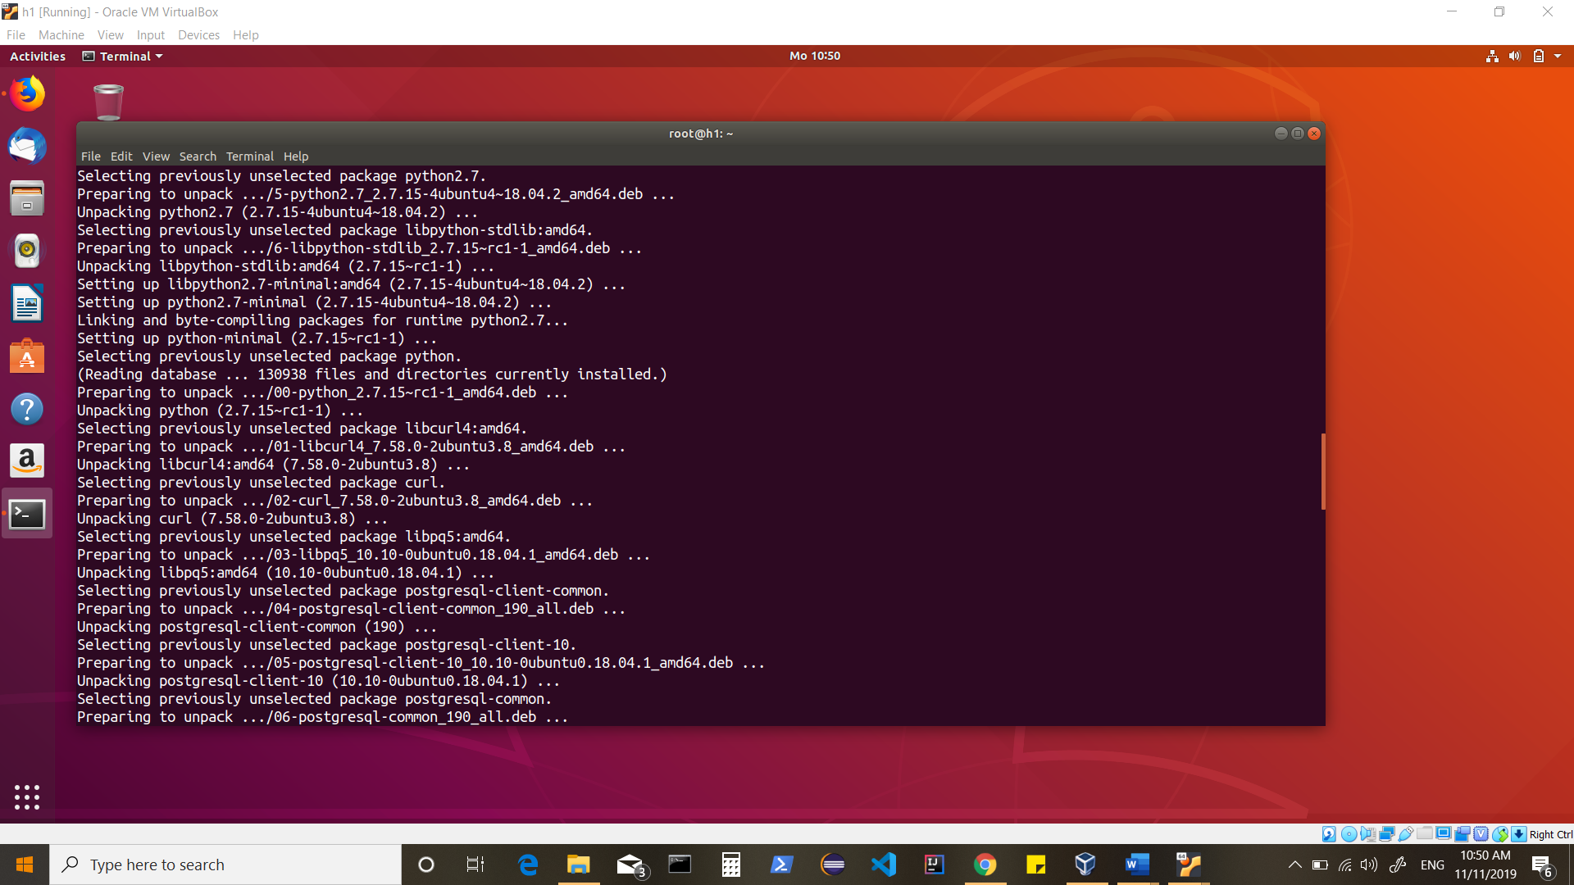

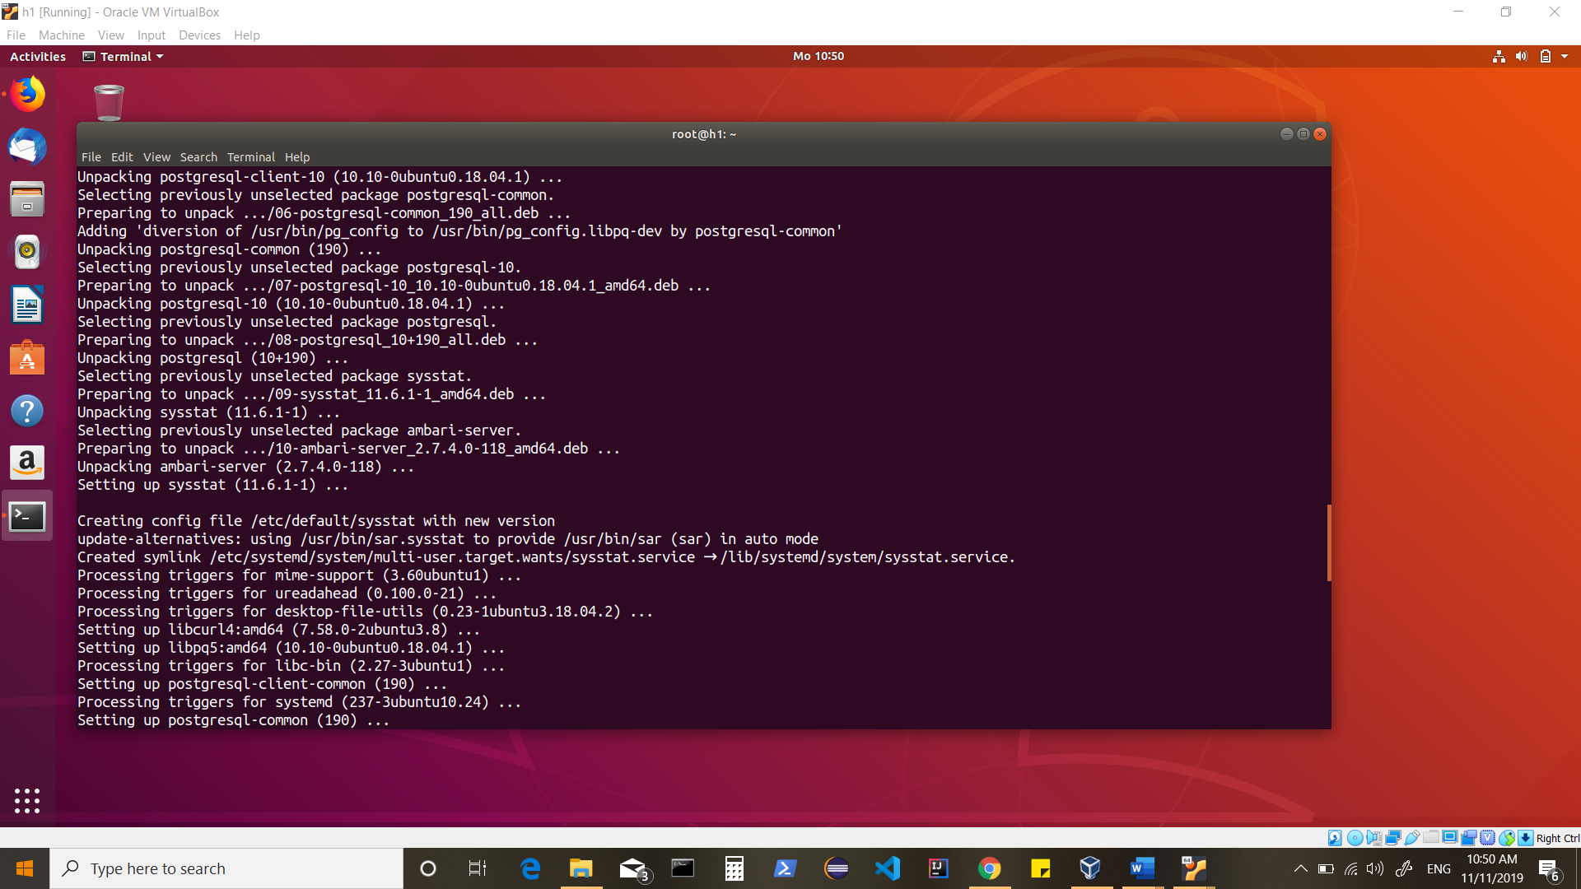

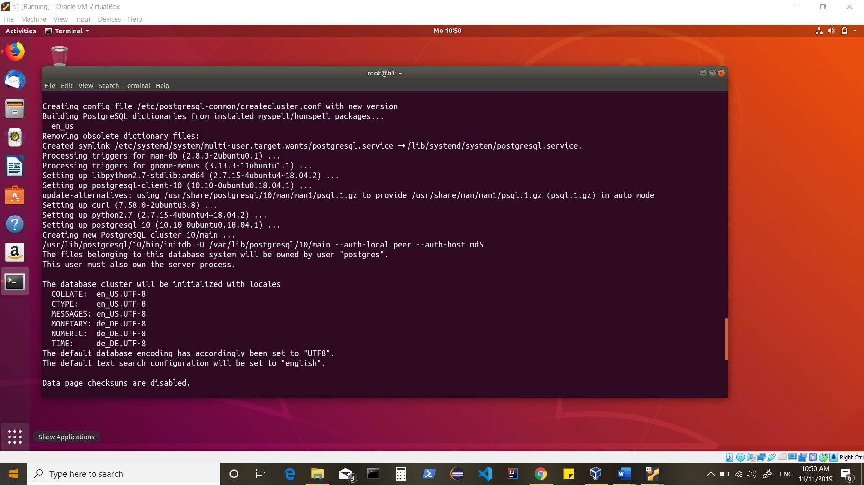

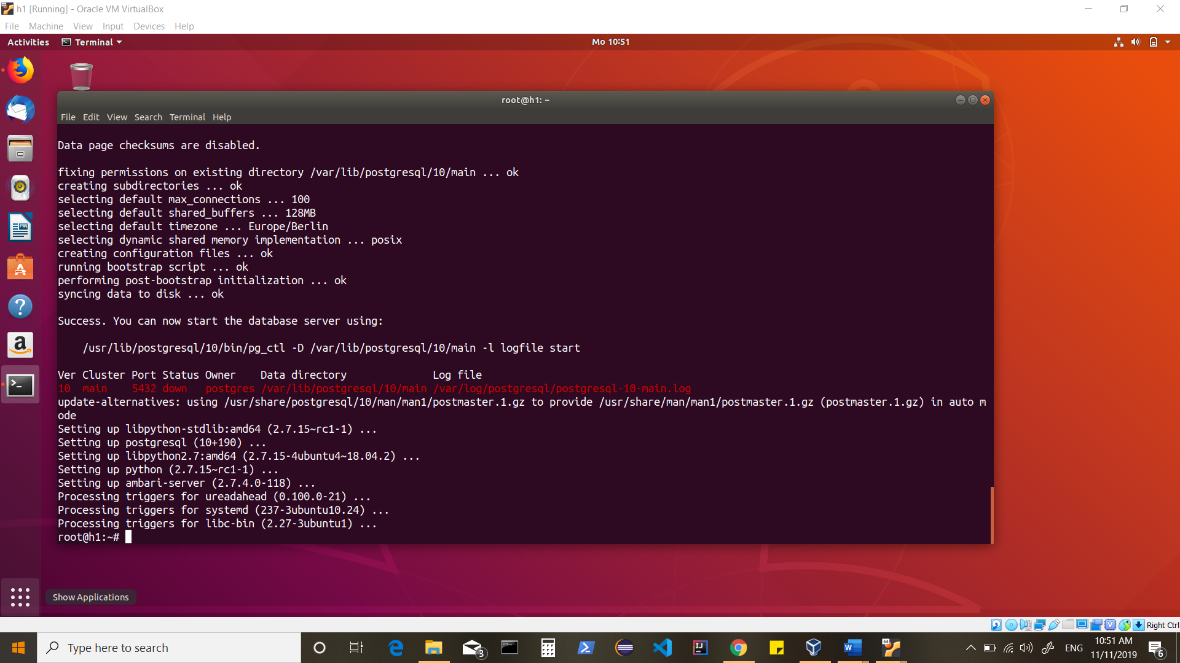

To start Postgres

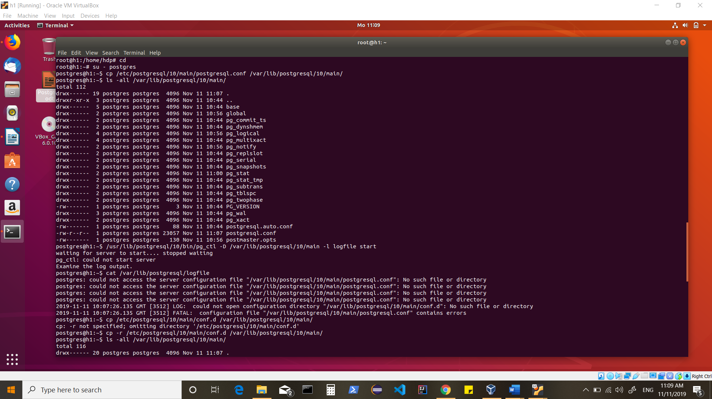

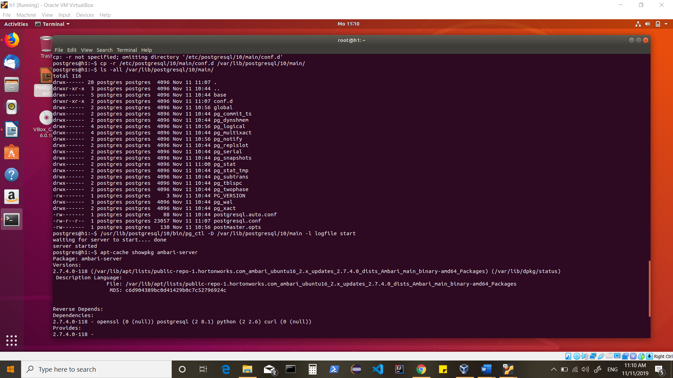

Confirm that Ambari packages downloaded successfully by checking the package name list.

apt-cache showpkg ambari-server

apt-cache showpkg ambari-agent

apt-cache showpkg ambari-metrics-assembly

You should see the Ambari packages in the list.

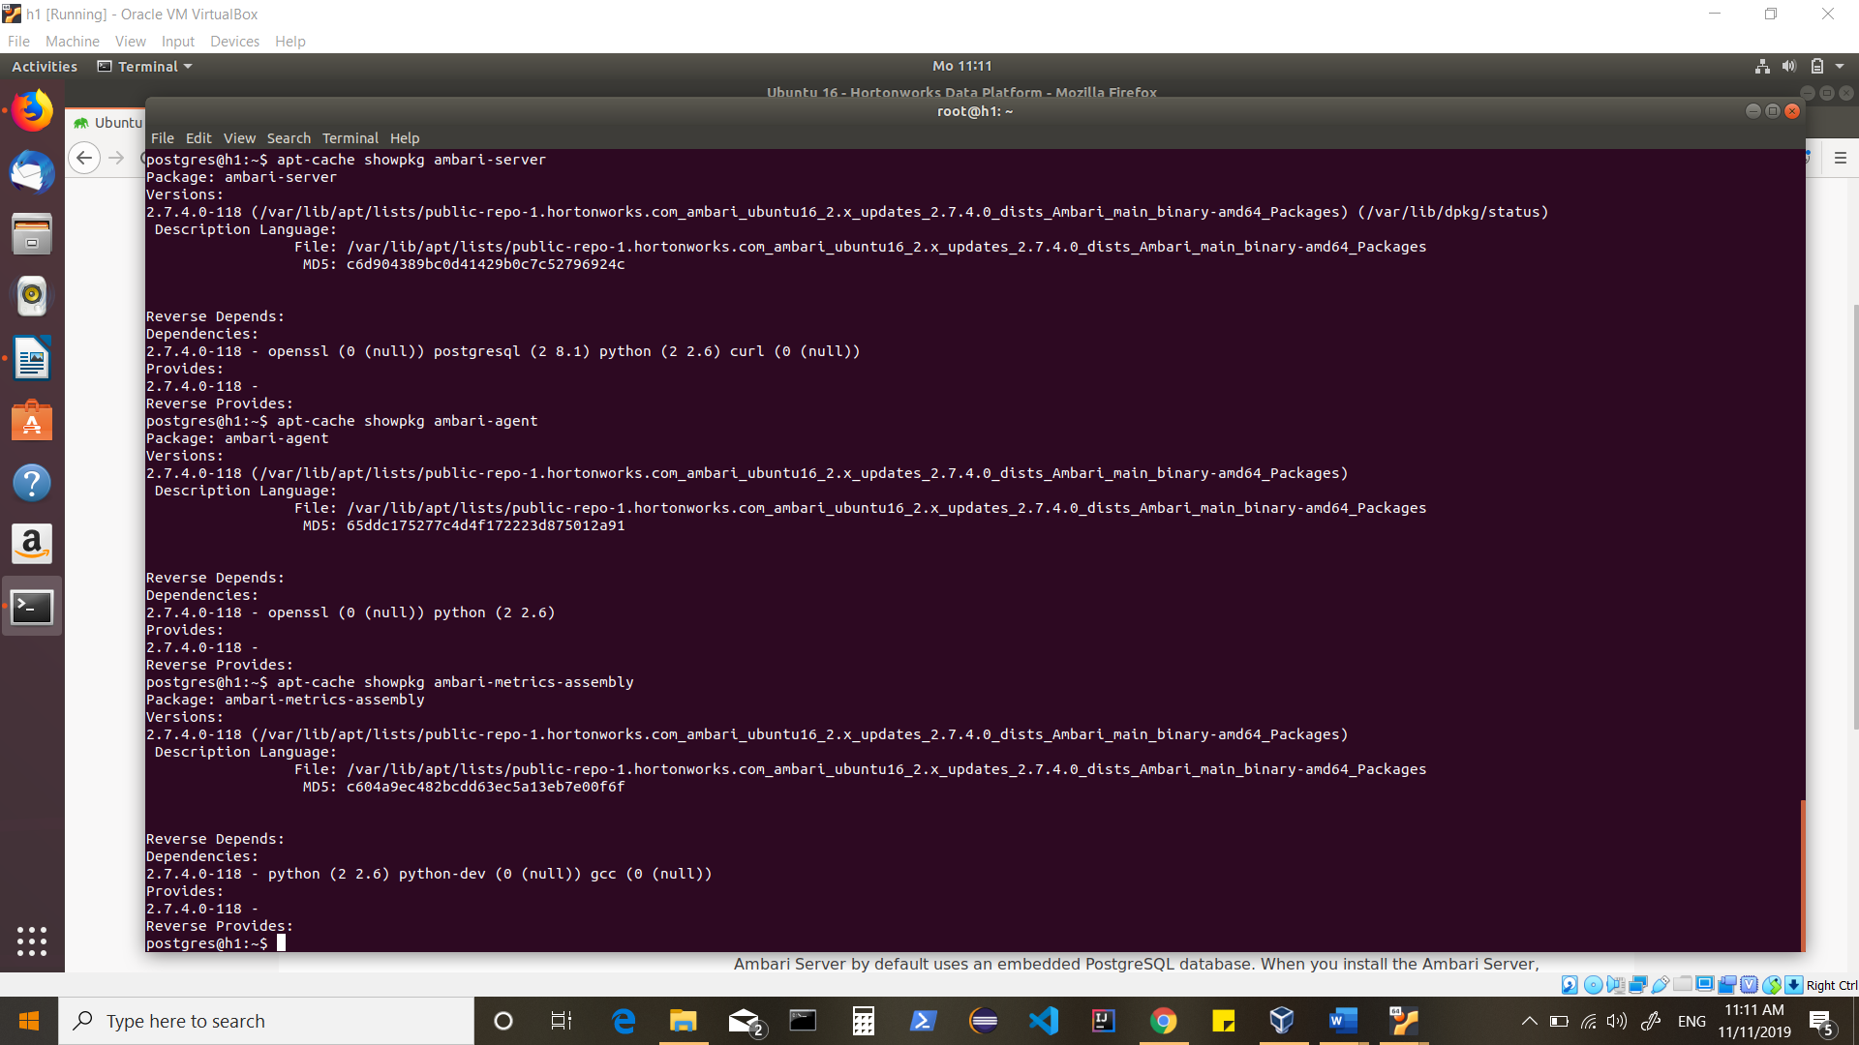

Ambari-server setup

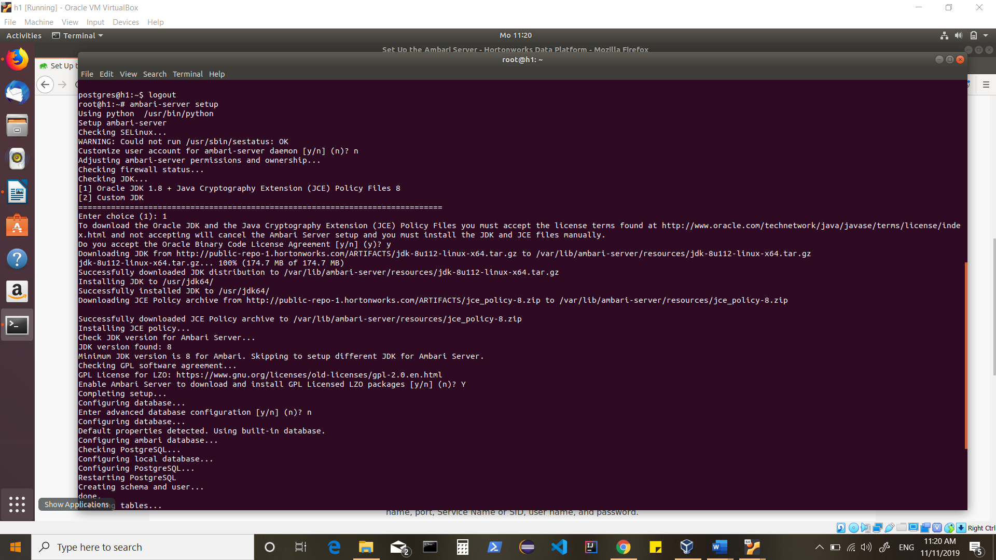

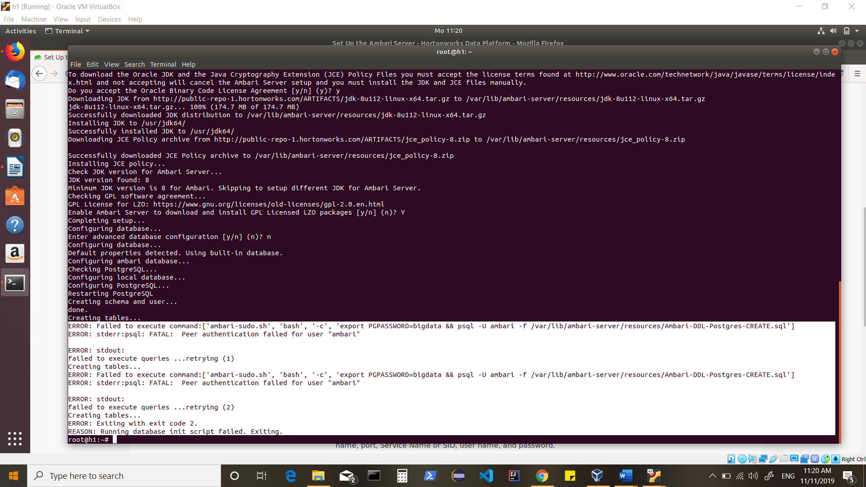

To fix this issue

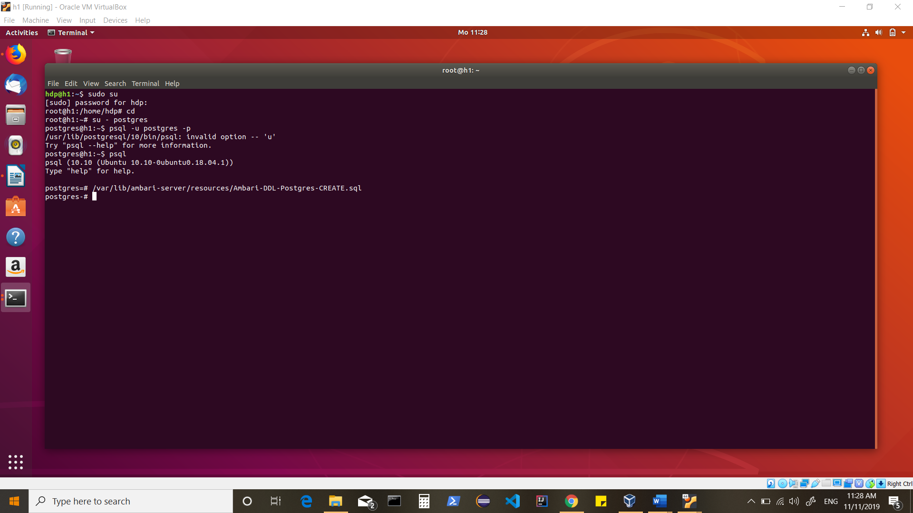

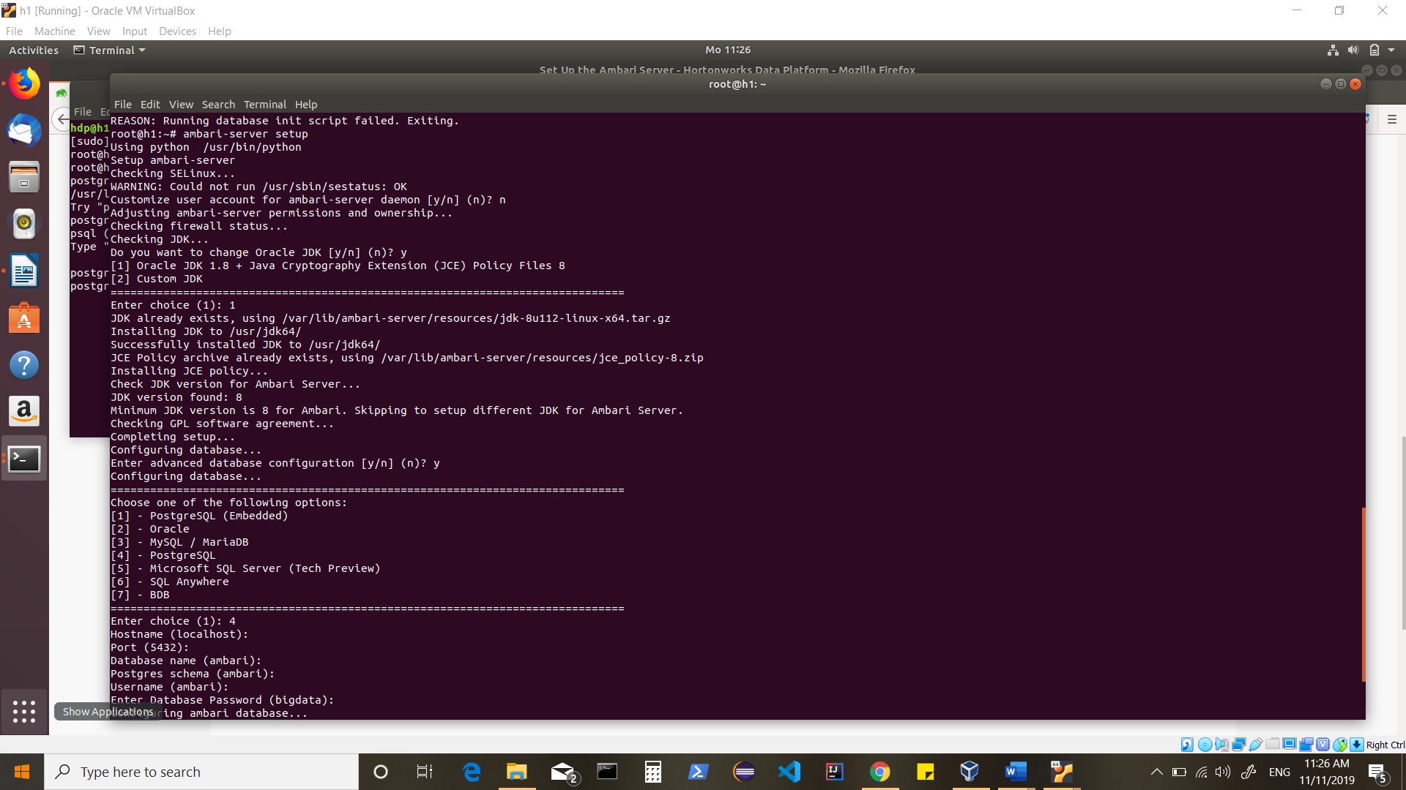

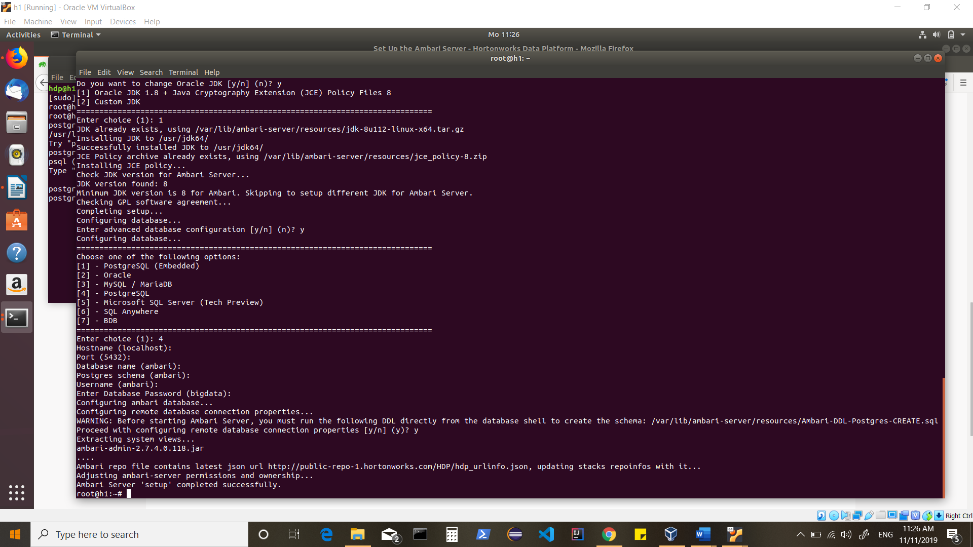

Ambari-server start

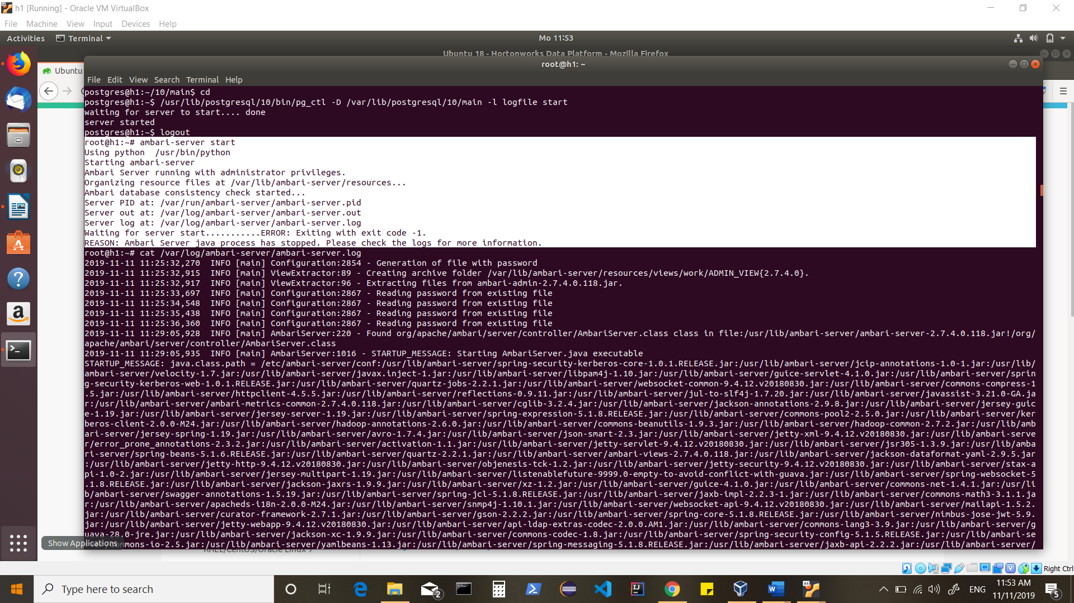

Looking in logs shows:

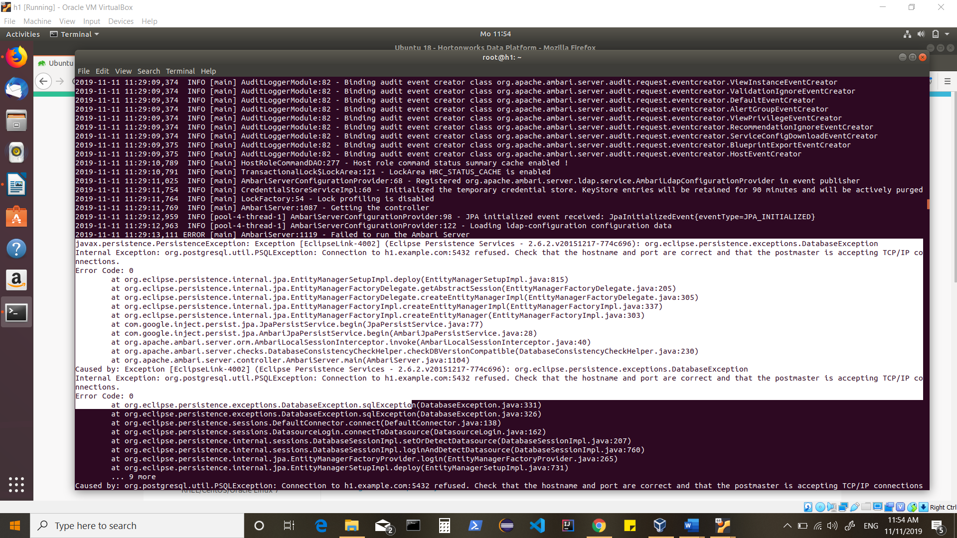

So postgres conf had to be changed to point to hostname (instead of localhost)

After Making changes, restart postgresql and try starting ambari-server

Error noticed:

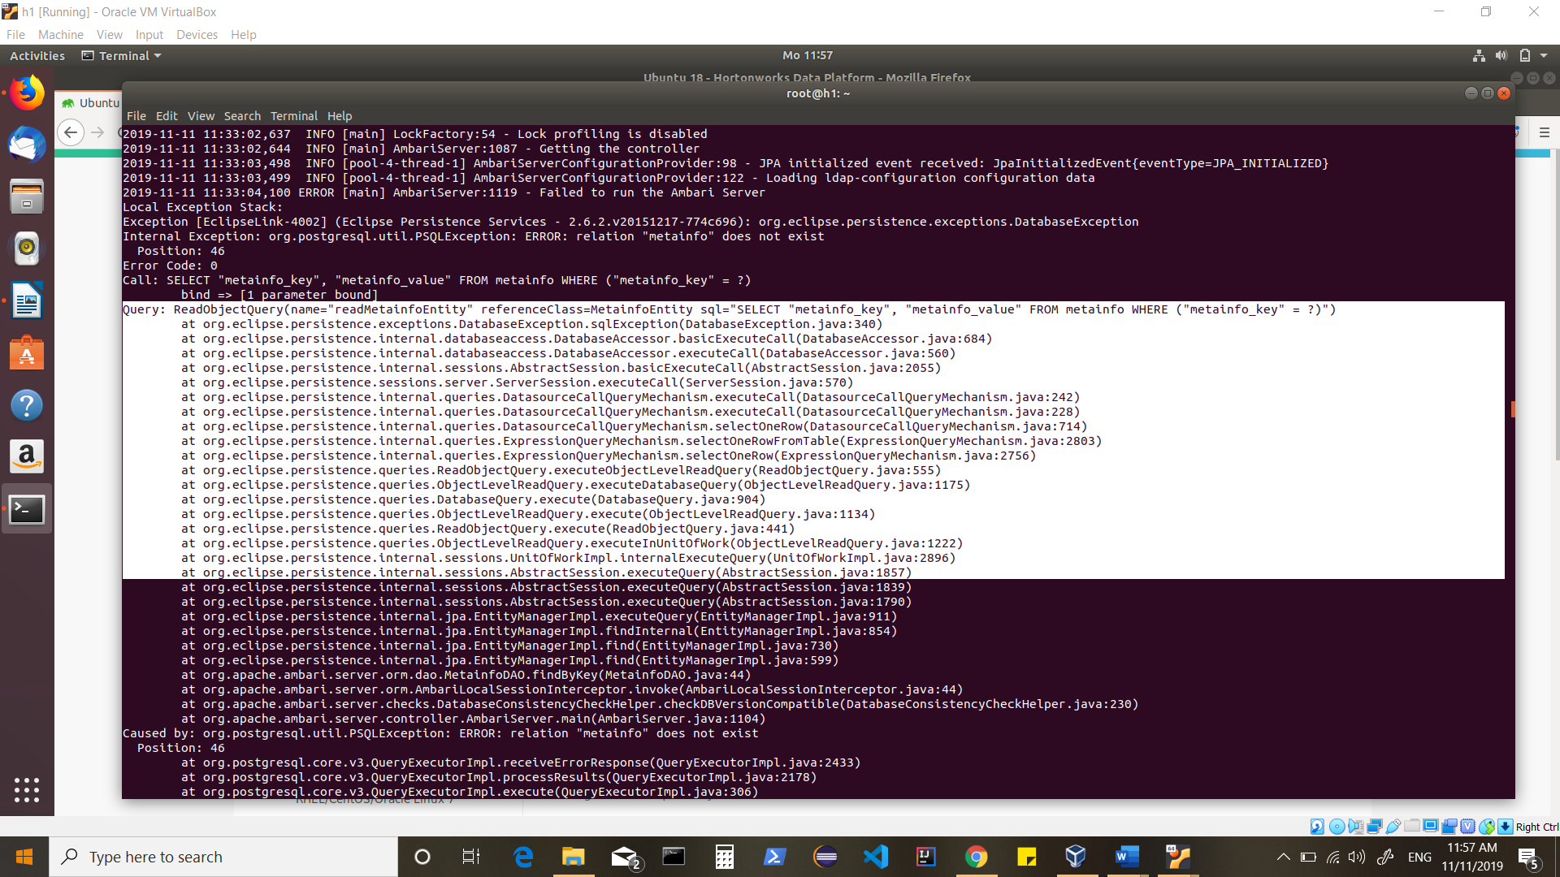

Attempted ‘ambari-server reset’ and then attempted ‘ambari-server setup’ again

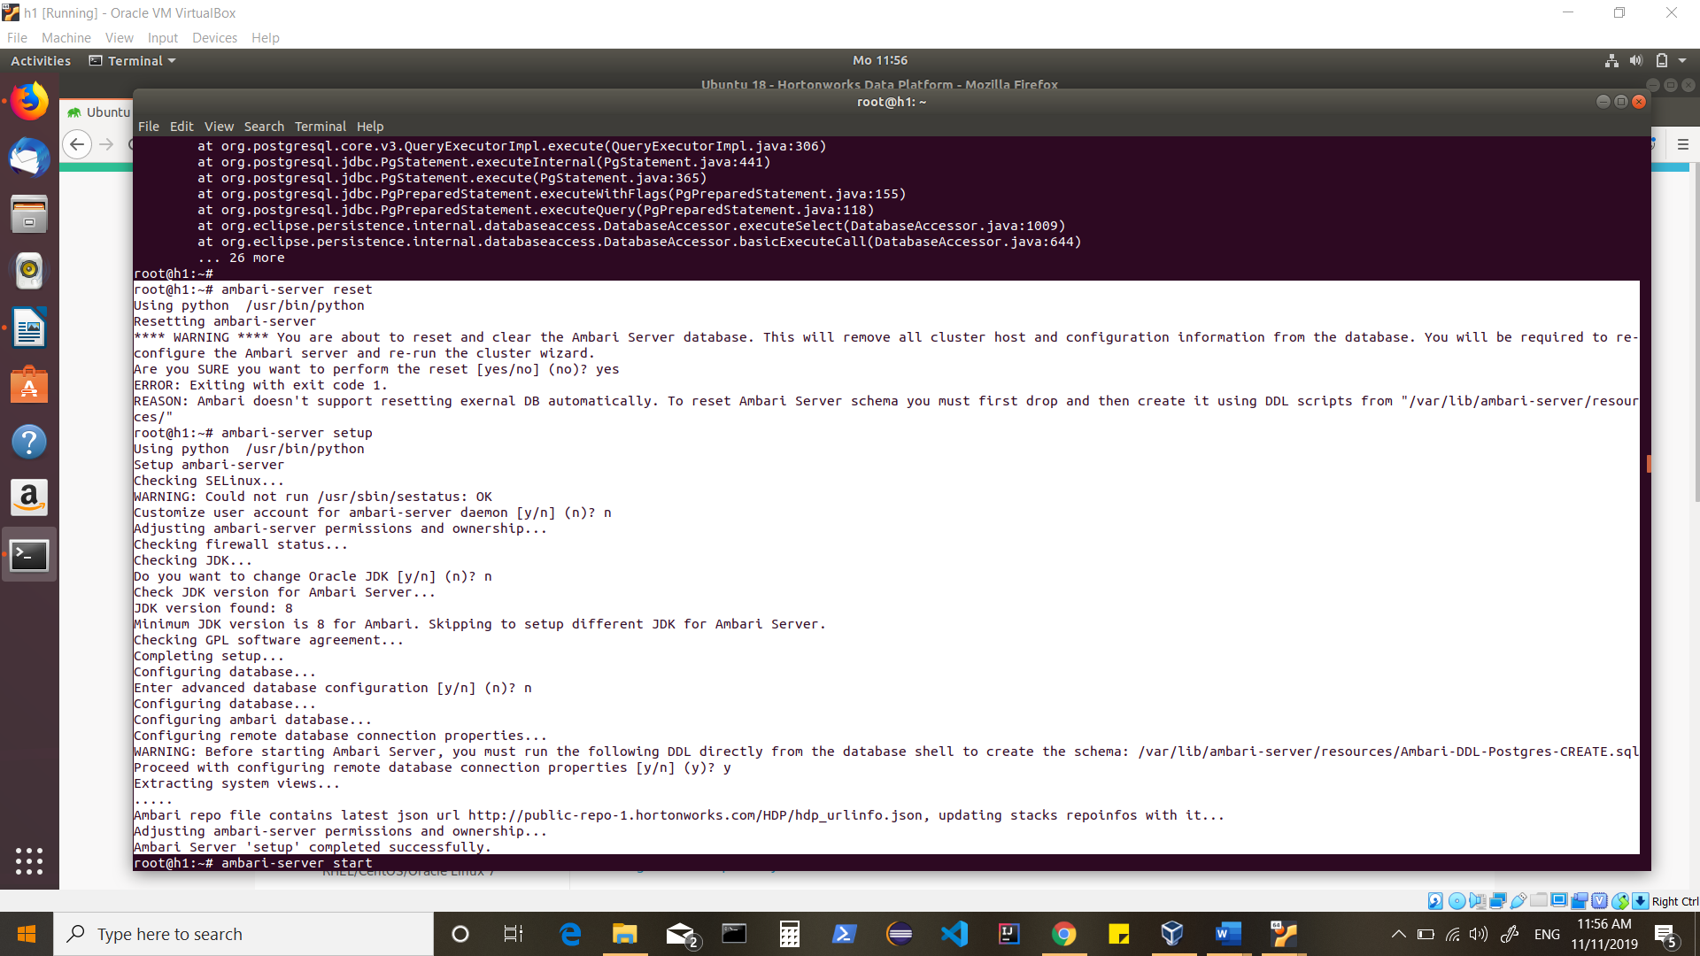

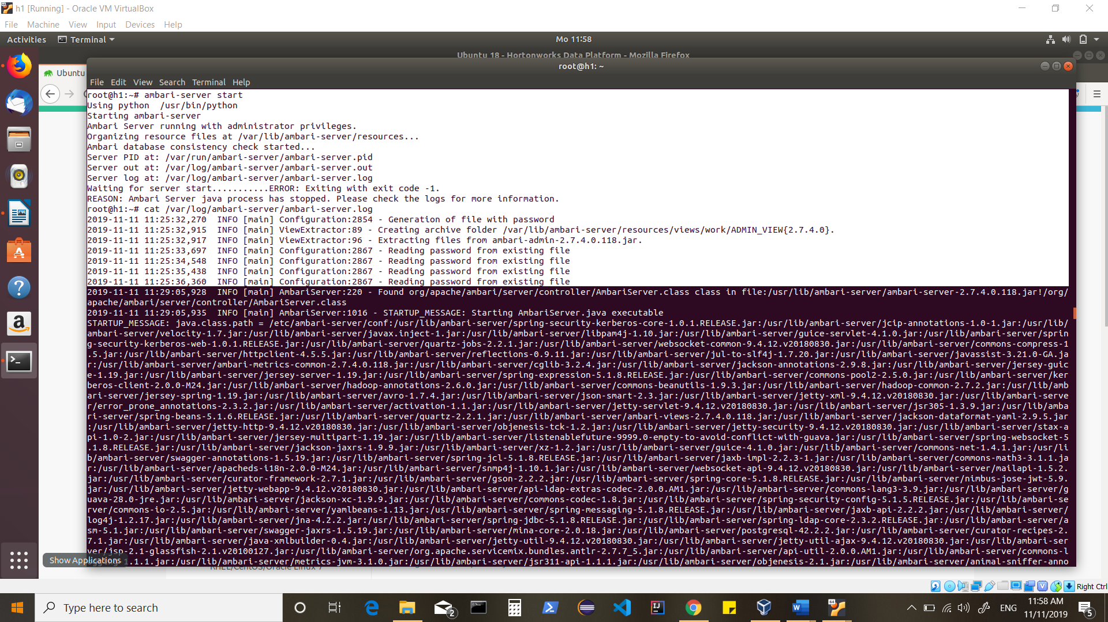

Thus…issue was postgresql setup

Removed postgresql (which also removed ambari-server)

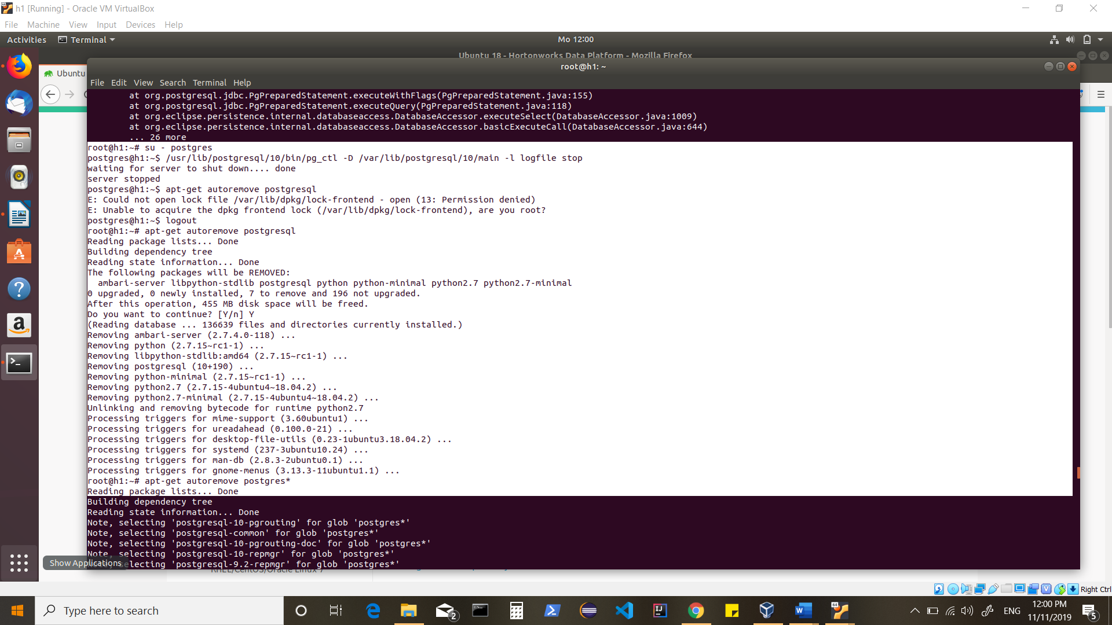

Alternatively we will go for defaults and not start Postgresql as we did earlier.

Install ambari-server

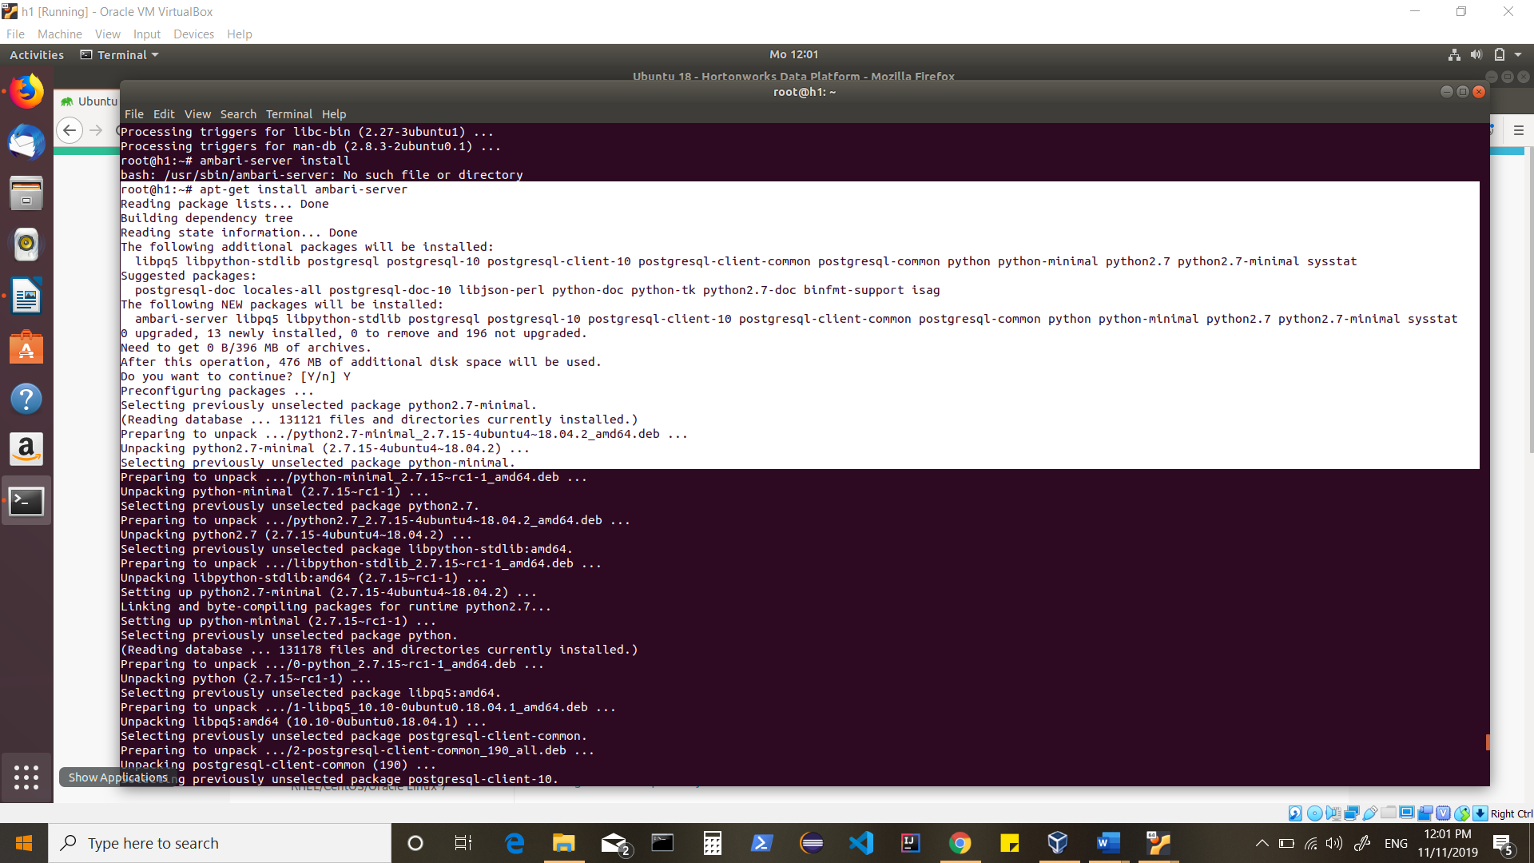

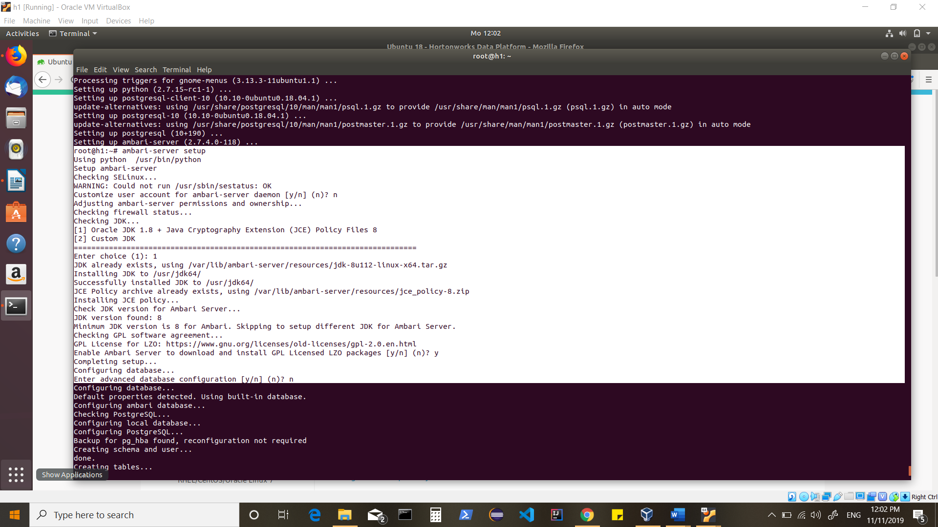

Start Ambari-server

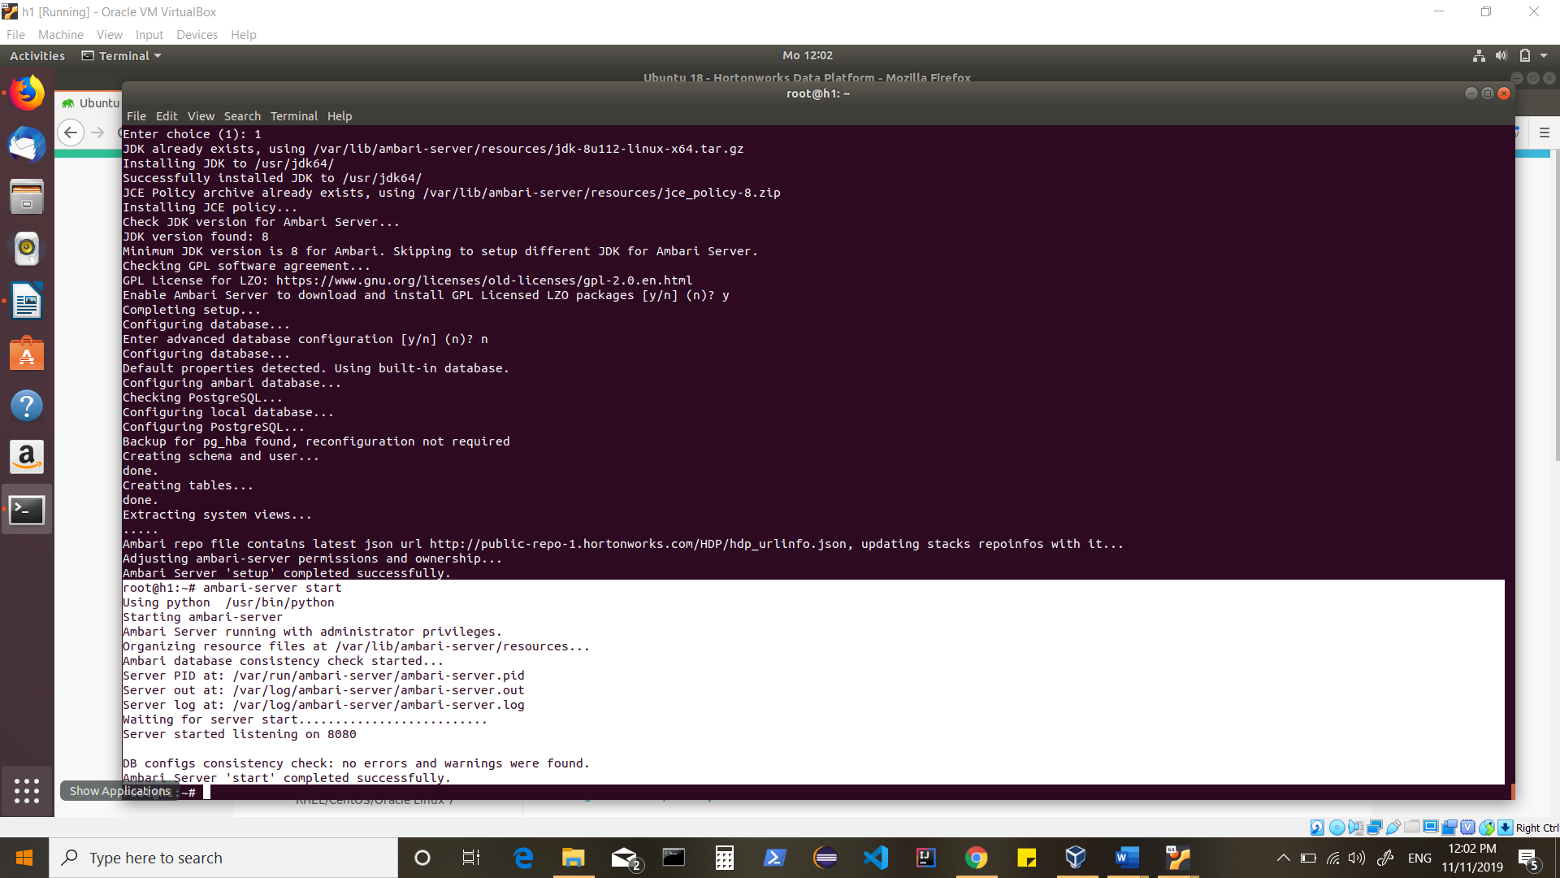

Bring up the Admin Console:

